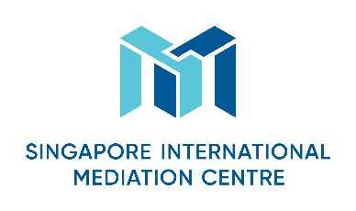
Specialist Mediator’s Curriculum Vitae
Personal Particulars
First Name
Linda (丽娜)

Last Name
Qiao (乔)
Designation
Senior International Counsel

Organisation
Rajah & Tann Singapore LLP Shanghai Representative Office
Nationality
Chinese
Languages (Native and/or professional working proficiency)
Chinese and English

Mediation Practice Areas
Please select as many areas as may be applicable.
Accountancy  Aviation & Airports  Banking/Finance  Business Interruption analysis  Energy  Information Technology  Intellectual Property  Infrastructure/Construction/Engineering  Maritime & Shipping Logistics | Mining  Workplace Health & Safety  Oil & Gas  Real Estate  Risk Management  Scientific Forensics  Sports Disputes (Law & Infrastructure)  Telecommunications  Others (please specify): _Merger & Acquisition, Joint Venture/Partnership; Hospitality (e.g. disputes relating to hotel management contracts) and general corporate_

Educational/Professional Background
LLB, China University of Political Science and Law
BA in English (with honours), Shenyang Normal University
Legal Profession Qualification Certificate (P.R. China)

Mediation Style
Mediation Experience
Mediation Education and Training
June 2018 – Attend the SIMC Specialist Mediation Workshop in Shanghai

Some Professional Affiliations
Legal Profession Qualification Certificate (P.R. China)

