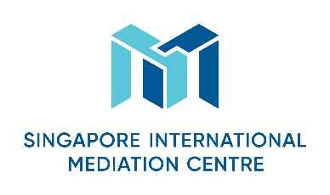
Mediator’s Curriculum Vitae
Personal Particulars
First Name
John

Last Name
Sturrock

Designation
QC

Organisation
Brick Court Chambers, London, and Core Solutions Group, Edinburgh

Nationality
British

Languages (Native and/or professional working proficiency)
English

Mediation Practice Areas
Please select as many areas as may be applicable.
X Accountancy  X Aviation & Airports  X Banking/Finance  X Business Interruption analysis  X Energy  X Information Technology  X Intellectual Property  X Infrastructure/Construction/Engineering  Maritime & Shipping Logistics | Mining  X Workplace Health & Safety  X Oil & Gas  X Real Estate  X Risk Management  Scientific Forensics  X Sports Disputes (Law & Infrastructure)  Telecommunications  X Others (please specify): Commercial Contracts, Public Sector, Government and Policy

Educational/Professional Background
LLB (Hons) (First Class)
LLM
LLD
Member of the Scottish Bar
Queen’s Counsel
Visiting Professor, the University of Edinburgh

Mediation Style
Facilitative / flexible / rigorous / encourages party autonomy

Mediation Experience
Extensive throughout UK, Europe, Africa, many hundreds of high- level mediations over 20 years

Mediation Education and Training
CEDR trained mediator
Many CPD and other training events over 20 years
Harvard Negotiation Course

Some Professional Affiliations
Distinguished Fellow, International Academy of Mediators
Member of the Faculty of Advocates
Door Tenant, Brick Court Chambers
Member, Chartered Institute of Arbitrators
Fellow of the Royal Society for the Arts

Testimonials (optional)
“spellbinding mediator and great thinker” and “by far the best in the market”.

“keen intellect”, “preparation to get at core issues” and “massive wealth of experience in difficult negotiation situations”.

“John is the best mediator I have met and has brought about a settlement in two cases which I thought resolution was impossible.”

