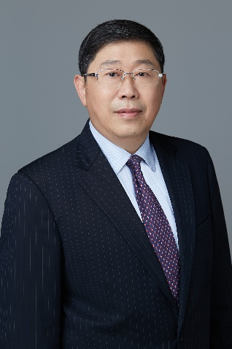
Ning FEI , Managing Partner
Suite 2304 One Indigo 20 Jiuxianqiao Road
Chaoyang District Beijing 100016
Direct Line: +86-10-5639-6588
E-mail: feining@huizhonglaw.com

Summary
Mr. Fei is the managing partner of Hui Zhong Law Firm, a boutique commercial dispute resolution law firm based in Beijing and Shanghai.
Mr. Fei specializes in commercial arbitration and litigation. He sits as arbitrator of China International Economic and Trade Arbitration Committee (CIETAC), Shenzhen Court of International Arbitration (SCIA), International Chamber of Commerce Court (ICC Court), Hong Kong International Arbitration Centre (HKIAC), Singapore International Arbitration Centre (SIAC), and Korean Commercial Arbitration Board (KCAB). Mr. Fei is also a member of SCIA Advisory Committee, and a Council Member of HKIAC, a title vested to persons from mainland China for the first time in history.
Mr. Fei has represented both Chinese and foreign clients in hundreds of commercial arbitration and litigation cases before domestic and overseas arbitral tribunals as well as PRC courts at various levels including the Supreme People’s Court. He has also participated in a dozen litigation or arbitral proceedings as expert witness on Chinese law in various forums located in Hong Kong, Singapore, the United Kingdom and the United States.
Since 2006, Mr. Fei has been ranked as Band 1 lawyer in the fields of arbitration and general dispute resolution in China by Chambers & Partners. He is described by Chambers & Partners as “a seasoned litigator and is admired for his high standard of professionalism. He excels in providing efficient, sensible commercial advice.”

