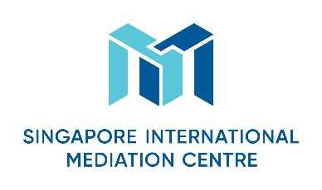
Specialist Mediator’s Curriculum Vitae
Personal Particulars
First Name
Jao Cheng

Last Name
Lin

Designation
Nil
Organisation
An-Tek & Co., CPAs
Nationality
Taiwanese

Languages (Native and/or professional working proficiency)
Mandarin, English

Mediation Practice Areas
Please select as many areas as may be applicable.
Accountancy  Aviation & Airports  Banking/Finance  Business Interruption analysis  Energy  Information Technology  Intellectual Property  Infrastructure/Construction/Engineering  Maritime & Shipping Logistics | Mining  Workplace Health & Safety  Oil & Gas  Real Estate  Risk Management  Scientific Forensics  Sports Disputes (Law & Infrastructure)  Telecommunications  Others (please specify): Professional negligence

Educational/Professional Background
Academic:
PhD of Shanghai University of Finance & Economics, P.R.C. (major in accountancy)
MBA of New York University, N.Y., U.S.A. (major in accountancy)
BA of National Cheng Chih University, R.O.C. (major in banking)

Professional Qualification:
Certified Public Accountant of New York State, U.S.A.
Certified Public Accountant of R.O.C.
Certified Public Accountant of P.R.C.

Mediation Style
Mediation Experience
Mediation Education and Training
1. 2017. 11 CCPIT Ningxia mediator training course
2. 2018.3 CCPIT-CEDR Wuhan mediator training course
3. 2018.6 CCPIT-SIMC Shanghai mediator training course

Some Professional Affiliations
Member of Beta Alpha Psi
Member of Beta Gamma Sigma
Member of AICPA
Member of ROCCPA
Arbitrator of Chinese Arbitration Association, Taipei
Mediator of CCPIT

`

