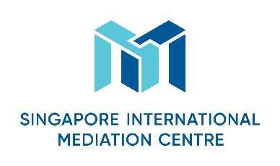
Specialist Mediator’s Curriculum Vitae
Personal Particulars
First Name
Xiao

Last Name
Jin

Designation
Partner

Organisation
Renhe Qibang (Hengqin)Joint Law Firm

Nationality
Chinese

Languages (Native and/or professional working proficiency)
Native Chinese and English
Mediation Practice Areas
Please select as many areas as may be applicable.
Accountancy  Aviation & Airports  Banking/Finance  Business Interruption analysis  Energy  Information Technology  Intellectual Property  Infrastructure/Construction/Engineering  Maritime & Shipping Logistics | Mining  Workplace Health & Safety  Oil & Gas  Real Estate  Risk Management  Scientific Forensics  Sports Disputes (Law & Infrastructure)  Telecommunications  Others (please specify): Mergers and acquisitions; International Trade

Educational/Professional Background
Xiao Jin was graduated from the National Huaqiao University, and later obtained her LL.M. from Stockholm University.
Ms. Jin has over 13 years’ enriched experience in the area of Intellectual Property and Information Technology, involving IP infringement litigation, IP-related business transactions and cross–border investments. She also has extensive experience in cross border investment, international trade, and international arbitration. She is among the few lawyers in China that has solid experience in cross examination in international arbitration and the U.S. International Trade Commission (ITC) 337 investigation cases. Ms. Jin is an active speaker on intellectual property law related to Internet and cross-border IP protection in various international and national conferences and seminars.
She has been awarded as “Leading Talents in Foreign-Related Lawyers” in 2013 and “Leading Talents in Young Lawyers” in 2017, by All China Lawyers Association. Ms. Jin has been listed on the panel of arbitrators of Guangzhou Arbitration Commission and Zhuhai Arbitration Commission, and she is also a mediator of China Council for the Promotion of International Trade (CCPIT).

Mediation Style
Mediation Experience
Mediation Education and Training
• CEDR’s Mediator Skills Training (March 2018, Wuhan)
• SIMC’s Specialist Mediator Workshop (June 2018, Shanghai)
Some Professional Affiliations
- Member, Tax law professional commission of All China Lawyers Association
- Mediation, China Council for the Promotion of International Trade
- Mediator, the People’s Conciliation Committee of Hunan Intellectual Property Bureau
- Arbitrator, Guangzhou Arbitration Commission
- Arbitrator, Zhuhai Arbitration Commission

