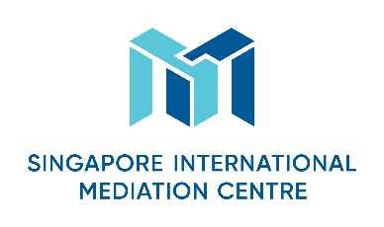
Mediator’s Curriculum Vitae
Personal Particulars
First Name
Karl

Last Name
Mackie

Designation
Dr Karl Mackie CBE

Organisation
CEDR

Nationality
British

Languages (Native and/or professional working proficiency)
English

Mediation Practice Areas
Please select as many areas as may be applicable.
Accountancy  X Aviation & Airports  X Banking/Finance  Business Interruption analysis  X Energy  X Information Technology  Intellectual Property  X Infrastructure/Construction/Engineering  Maritime & Shipping Logistics | Mining  Workplace Health & Safety  X Oil & Gas  X Real Estate  Risk Management  Scientific Forensics  X Sports Disputes (Law & Infrastructure)  X Telecommunications  Others (please specify): Business and human rights; investor-state; corporate governance.

Educational/Professional Background
MA Hons Psychology University of Edinburgh
LLB University of London
MBA Open University
PhD University of Nottingham
Bar Finals, Gray’s Inn,London
Chartered Psychologist, BPS
Fellow of the Chartered Institute of Arbitrators
CEDR Accredited Mediator

Mediation Style
Mediation Experience
Extensive experience across all sectors and both in UK and internationally as one of the founders of CEDR in 1990. Described as ‘Mr Mediation’ in the Law Section of The Times. See full CV.

Mediation Education and Training
CEDR Accredited
Involved in training or organising training for many hundreds of mediators in UK and internationally

Some Professional Affiliations
Listed on numerous international panels of mediators eg – ACAS; CEDR; CPR; CIETAC; SIMC; UN.
Founding President CEDR
Deputy Chairman for 5 years of the Civil Mediation Council of the UK
Board member for 4 years of the International Mediation Institute
Visiting Professor in ADR

Testimonials (optional)
See above and full CV

