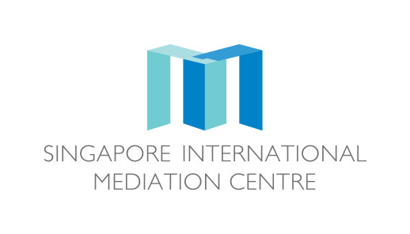

**SIMC Specialist Mediator’s Curriculum Vitae**

|  |  |
| --- | --- |
| **Personal Particulars** | |
| First Name | Liz Kyo-Hwa |
| Surname | Chung |
| Designation | Partner |
| Organisation | Kim & Chang |
| **Educational/Professional Background** | |
| **Education**   * Harvard Law School (LL.M., 2008) * Judicial Research and Training Institute of the Supreme Court of Korea (1999) * College of Law, Korea University (LL.B., 1996) * Admitted to bar, Korea, 1999; New York, 2009   **Professional Background**   * Arbitrator/Neutral, KCAB; HKIAC; SIAC; WIPO * Mediator, Korea Contents Dispute Mediation Commission (2014-Present); Mediation Commission under the Korea Intellectual Property Office (2013-Present) * Member, Seoul Metropolitan City’s Administrative Appeals Committee (2005-2007, 2013-2015) * Kim & Chang (2003-Present) * Skadden, Arps, Slate, Meagher & Flom LLP, New York, International Visiting Attorney (2008-2009) * Judge, Seoul District Court, Supreme Court, Seoul Administrative Court (1999-2003) | |
| **Mediation Education and Training** | |
| SIMC Specialist Mediator Workshop (25-26 Jan 2018)  Harvard Mediation Program (2008) | |
| **Some Professional Affiliations** | |
| * SIMC Users Council, Member (2017-Present) * SIAC Users Council, Member (2015-Present) * Member, Chartered Institute of Arbitrators (CIArb) * Officer, IBA Arbitration Committee (2018-present) * Member, Korea Council of International Arbitration (KOCIA)   **Publication**  Getting the Deal Through - Arbitration: Korea Chapter (Co-author, Law Business Research, 2016)  Korea's Experience with International Investment Agreements and Investor State Dispute Settlement (Co-author, The Journal of World Investment & Trade, 16 (2015))  The Backlash Against Investment Arbitration (Co-editor, Kluwer Law International, 2010) | |