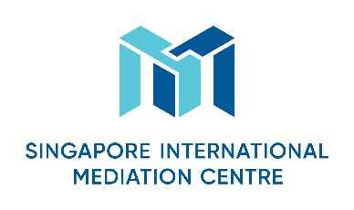
Specialist Mediator’s Curriculum Vitae
Personal Particulars
First Name
Lei雷

Last Name
LI李

Designation
Senior Legal Consultant高级法律顾问

Organisation
Wong Partnership Shanghai Office 新加坡王律师事务所上海代表处
Nationality
Chinese
Languages (Native and/or professional working proficiency)
Chinese (native), English (professional working proficiency), Japanese (professional working proficiency)
中文（母语），英文（专业娴熟），日语（专业娴熟）

Mediation Practice Areas
Please select as many areas as may be applicable.
Accountancy  Aviation & Airports  Banking/Finance  Business Interruption analysis  Energy  Information Technology  Intellectual Property  Infrastructure/Construction/Engineering  Maritime & Shipping Logistics | Mining  Workplace Health & Safety  Oil & Gas  Real Estate  Risk Management  Scientific Forensics  Sports Disputes (Law & Infrastructure)  Telecommunications  Others (please specify): Hotel & Hospitality

Educational/Professional Background
Admitted to Bar in the PRC, 2001
获得中国律师资格，2001
Master of Laws, University of International Business and Economics, 2002~ 2005
法学硕士，对外经济贸易大学，2002~2005
Beijing Huamao & Guigu Law Firm, 2005~2007
北京华贸硅谷律师事务所，2005~2007
Wong Partnership LLP Shanghai Office, 2007 to date
新加坡王律师事务所上海代表处，2007至今

Mediation Style
Facilitative
促进型

Mediation Experience
Attended ad hoc mediation and various court/arbitration related mediations
参与了临时调解和各种法院/仲裁相关的调解

Mediation Education and Training
Specialist Mediation Workshop 2018 (SMW), SIMC
专家调解培训讲座 2018， 新加坡国际调解中心
Mediator Training Seminar 2018, CCPIT/CCOIC Mediation Centre
调解员培训讲座2018，中国贸促会/中国国际商会调解中心

Some Professional Affiliations
Arbitrator, Harbin Arbitration Commission
哈尔滨仲裁委员会仲裁员
Mediator, CCPIT/CCOIC Mediation Centre
中国贸促会/中国国际商会调解中心调解员
Member, The Chartered Institute of Arbitrators (MCIArb)
英国皇家特许仲裁员协会正式会员
Chartered Builder, The Chartered Institute of Building (MCIOB)
英国皇家特许建造师学会特许建造师

